/*
* Chris Tjon - Ex5.9 Wed 4pm
*
*/
package doubled;

import java.applet.Applet;
import java.awt.Graphics;
import java.awt.*;
import java.awt.event.*;

public class Doubled extends Applet implements ActionListener
{
private TextField inputField;
private int input;

int doubled(int operand)
{
return(operand * 2); // double the parameter and return it
}

public void init()
{
Label fieldName = new Label("Input:");
add(fieldName);
inputField = new TextField(5);
add(inputField);
inputField.addActionListener(this);
}

public void actionPerformed(ActionEvent event)
{
input = Integer.parseInt(inputField.getText());
repaint();
}

public void paint(Graphics g)
{
g.drawString("doubled(" + input + ") = " + doubled(input), 50, 50);
}
}
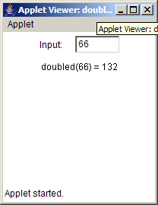

/*
* Chris Tjon, Ex 6.4 Wed 4pm
*/
package filledOval;

import java.awt.*;
import java.applet.Applet;
import java.awt.event.*; //mp

public class FilledOval extends Applet implements AdjustmentListener
{
private Scrollbar lengthBar, heightBar;
private int height, length;

public void init() {
Label lengthLabel = new Label ("Length");
add(lengthLabel);
lengthBar = new Scrollbar(Scrollbar.HORIZONTAL, 0, 10, 100, 1000);
add(lengthBar);
lengthBar.addAdjustmentListener(this);

Label heightLabel = new Label ("Height");
add(heightLabel);
heightBar = new Scrollbar(Scrollbar.VERTICAL, 0, 10, 100, 1000);
add(heightBar);
heightBar.addAdjustmentListener(this);
}

public void adjustmentValueChanged(AdjustmentEvent e)
{
length = lengthBar.getValue();
height = heightBar.getValue();
repaint();
}

public void paint(Graphics g)
{
g.fillOval(40, 60, length, height);
}
}

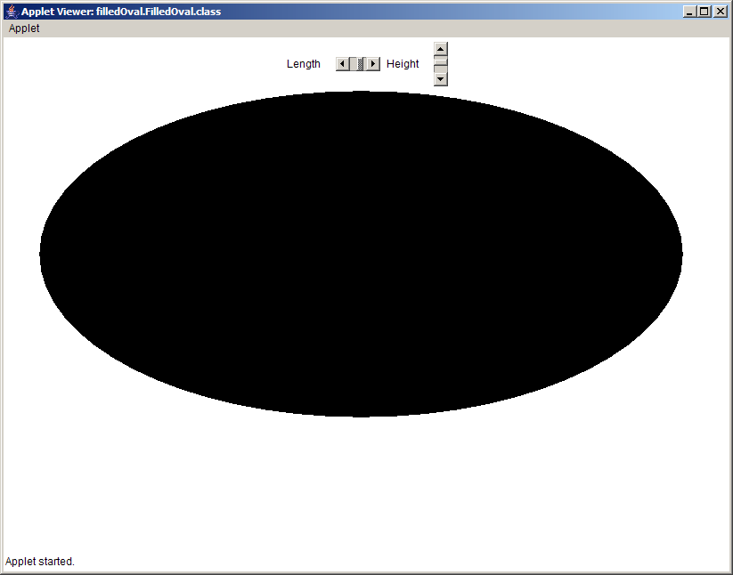

/*
* Chris Tjon, Ex 7.4 Wed 4pm
*/
package agecheck;

import java.applet.*;
import java.awt.*;
import java.awt.event.*;

public class AgeCheck extends Applet implements AdjustmentListener {

private Scrollbar ageBar;
private int age;

public void init() {
Label ageLabel = new Label ("Age:");
add(ageLabel);
ageBar = new Scrollbar(Scrollbar.HORIZONTAL, 0, 1, 0, 100);
add(ageBar);
ageBar.addAdjustmentListener(this);
}

public void adjustmentValueChanged(AdjustmentEvent e)
{
age = ageBar.getValue();
repaint();
}

public void paint (Graphics g)
{
g.drawString("Age is " + age, 50, 50);
if (age < 5)
g.drawString("Free", 50, 100);
else if (age < 13)
g.drawString("Half Price", 50,100);
else if (age < 55)
g.drawString("Full Price", 50,100);
else if (age > 54)
g.drawString("Free", 50,100);
}

}

